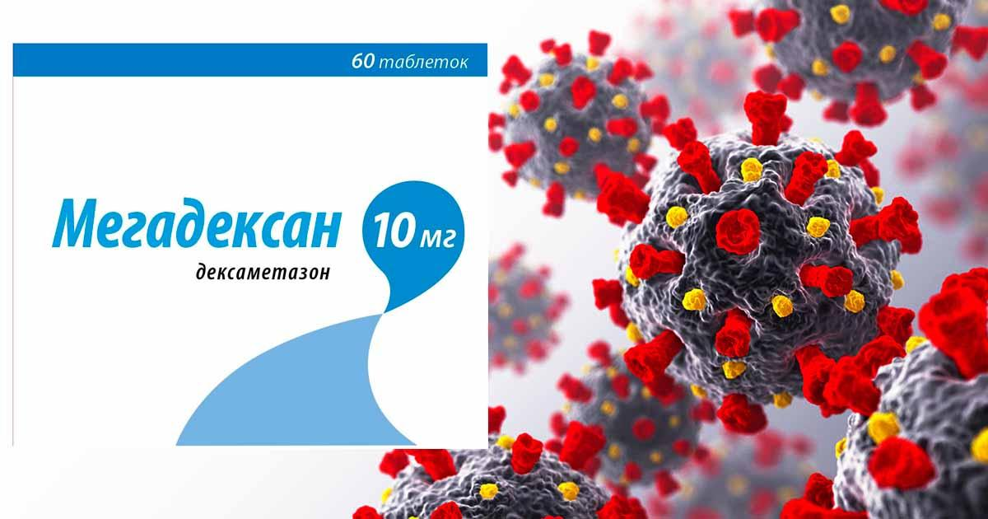

Список литературы

- Сavalcanti et al.Coalition Covid-19 Brazil I Investigators. Hydroxychloroquine with or without Azithromycin in Mild-to-Moderate Covid-19. N Engl J Med. 2020 Nov 19;383(21):2041-2052. doi: 10.1056/NEJMoa2019014. Epub 2020 Jul 23. Erratum in: N Engl J Med. 2020 Nov 19;383(21):e119. PMID: 32706953; PMCID: PMC7397242.
- Bozzette SA, Sattler FR, Chiu J, et al. A controlled trial of early adjunctive treatment with corticosteroids for Pneumocystis carinii pneumonia in the acquired immunodeficiency syndrome. California Collaborative Treatment Group. N Engl J Med. 1990;323(21):1451-1457.
- [Guideline] Clinical management of severe acute respiratory infection when novel coronavirus (nCoV) infection is suspected. World Health Organization.
- Arabi YM, Mandourah Y, Al-Hameed F, et al. Corticosteroid therapy for critically ill patients with Middle East respiratory syndrome. Am J Respir Crit Care Med. 2018;197(6):757-767.
- Stockman LJ, Bellamy R, Garner P. SARS: systematic review of treatment effects. PLoS Med. 2006;3(9):e343.
- Rodrigo C, Leonardi-Bee J, Nguyen-Van-Tam J, Lim WS. Corticosteroids as adjunctive therapy in the treatment of influenza. Cochrane Database Syst Rev. 2016;3:CD010406.
- Meduri GU, Bridges L, Shih MC, Marik PE, Siemieniuk RAC, Kocak M. Prolonged glucocorticoid treatment is associated with improved ARDS outcomes: analysis of individual patients' data from four randomized trials and trial-level meta-analysis of the updated literature. Intensive Care Med. 2016;42(5):829-840.
- Meduri GU, Golden E, Freire AX, et al. Methylprednisolone infusion in early severe ARDS: results of a randomized controlled trial. Chest. 2007;131(4):954-963.
- Steinberg KP, Hudson LD, Goodman RB, et al. Efficacy and safety of corticosteroids for persistent acute respiratory distress syndrome. N Engl J Med. 2006;354(16):1671-1684.
- Liu L, Li J, Huang YZ, et al. [The effect of stress dose glucocorticoid on patients with acute respiratory distress syndrome combined with critical illness-related corticosteroid insufficiency]. Zhonghua Nei Ke Za Zhi. 2012;51(8):599-603.
- Villar J, Ferrando C, Martinez D, et al. Dexamethasone treatment for the acute respiratory distress syndrome: a multicentre, randomised controlled trial. Lancet Respir Med. 2020;8(3):267-276.
- Rezk NA, Ibrahim AM. Effects of methyl prednisolone in early ARDS. Egyptian Journal of Chest Diseases and Tuberculosis. 2013;62(1):167-172.
- ongyoo S, Permpikul C, Mongkolpun W, et al. Hydrocortisone treatment in early sepsis-associated acute respiratory distress syndrome: results of a randomized controlled trial. Crit Care. 2016;20(1):329.
- Zhao WB, Wan SX, Gu DF, Shi B. Therapeutic effect of glucocorticoid inhalation for pulmonary fibrosis in ARDS patients. Medical Journal of Chinese People's Liberation Army. 2014;39(9):741-745.
- Mammen MJ, Aryal K, Alhazzani W, Alexander PE. Corticosteroids for patients with acute respiratory distress syndrome: a siystematic review and meta-analysis of randomized trials. Pol Arch Intern Med. 2020;130(4):276-286.
- Alhazzani W, Moller MH, Arabi YM, et al. Surviving Sepsis Campaign: guidelines on the management of critically ill adults with coronavirus disease 2019 (COVID-19). Crit Care Med. 2020;48(6):e440-e469.
- RECOVERY Collaborative Group, Horby P, Lim WS, et al. Dexamethasone in hospitalized patients with COVID-19. N Engl J Med. 2021;384(8):693-704.
- 16 RECOVERY Collaborative Group. Tocilizumab in patients admitted to hospital with COVID-19 (RECOVERY): a randomised, controlled, open-label, platform trial. Lancet. 2021;397(10285):1637-1645.
- WHO Rapid Evidence Appraisal for COVID-19 Therapies (REACT) Working Group, Sterne JAC, Murthy S, et al. Association Between Administration of Systemic Corticosteroids and Mortality Among Critically Ill Patients With COVID-19: A Meta-analysis. JAMA 2020; 324:1330.
- Siemieniuk RA, Bartoszko JJ, Ge L, et al. Drug treatments for covid-19: living systematic review and network meta-analysis. BMJ 2020; 370:m2980.
- COVID-19 living network meta-analysis http://www.covid19lnma.com/ (Accessed on September 07, 2021).
- Wagner C, Griesel M, Mikolajewska A, et al. Systemic corticosteroids for the treatment of COVID-19. Cochrane Database Syst Rev 2021; 8:CD014963.
- REMAP-CAP Investigators, Gordon AC, Mouncey PR, et al. Interleukin-6 receptor antagonists in critically ill patients with COVID-19. N Engl J Med. 2021;384(16):1491-1502.
- Marconi VC, Ramanan AV, de Bono S, et al. Baricitinib plus standard of care for hospitalized adults with COVID-19.
- Czock D, Keller F, Rasche FM, Haussler U. Pharmacokinetics and pharmacodynamics of systemically administered glucocorticoids. Clin Pharmacokinet. 2005;44(1):61-98.
- Garg D, Muthu V, Sehgal IS, et al. Coronavirus disease (COVID-19) associated mucormycosis (CAM): case report and systematic review of literature. Mycopathologia. 2021;186(2):289-298.
- Moorthy A, Gaikwad R, Krishna S, et al. SARS-CoV-2, uncontrolled diabetes and corticosteroids—an unholy trinity in invasive fungal infections of the maxillofacial region? A retrospective, multi-centric analysis. J Maxillofac Oral Surg. 2021:1-8
- Machado M, Valerio M, Alvarez-Uria A, et al. Invasive pulmonary aspergillosis in the COVID-19 era: An expected new entity. Mycoses. 2021;64(2):132-143.
- Chauvet P, Mallat J, Arumadura C, et al. Risk factors for invasive pulmonary aspergillosis in critically ill patients with coronavirus disease 2019-induced acute respiratory distress syndrome. Crit Care Explor. 2020;2(11):e0244.
- Liu J, Wang T, Cai Q, et al. Longitudinal changes of liver function and hepatitis B reactivation in COVID-19 patients with pre-existing chronic HBV infection. Hepatol Res. 2020;50(11):1211-1221.

